
School of Computing
Department of Artificial Intelligence and Machine Learning
DATA ANALYSIS ESSENTIALS

C O R N E R S T O N E P R O J E C T
LIBRARY MANAGEMENT SYSTEM

Submitted in partial fulfilment of the requirements for the award of the B.Tech. degree in Artificial Intelligence and Machine Learning

S U B M I T T E D B Y

B.V.V.SATYANARAYANA | (26B21AI014)
G.D.ESWAR SHANMUKH | (26B21AI034)
S.T.N.V.GANESH | (26B21AI071)
G.SAI CHARAN | (26B21AI043)

P R O J E C T G U I D E

Bh. Sai Venkata Ganesh
Assistant Professor, Department of AIML

ADITYA UNIVERSITY, SURAMPALEM
Academic Year 2026 – 2027

School of Computing

Department of Artificial Intelligence and Machine Learning DATA ANALYSIS ESSENTIALS
CERTIFICATE

This is to certify that the Cornerstone project work entitled “LIBRARY MANAGEMENT SYSTEM” is submitted by

B.V.V.SATYANARAYANA | (26B21AI014)
G.D.ESWAR SHANMUKH | (26B21AI034)
S.T.N.V.GANESH | (26B21AI071)
G.SAI CHARAN | (26B21AI043)

in partial fulfilment of the requirements for the award of the B.Tech. degree in Artificial Intelligence and Machine Learning during the academic year 2026–2027.

Project Guide  Bh.Sai Venkata Ganesh, M.Tech Assistant Professor  Department of AIML | Head of the Department Dr. K. Naga Bhargavi, Ph.D Associate Professor & HOD  Department of AIML

DECLARATION

We hereby declare that the project entitled “LIBRARY MANAGEMENT SYSTEM” is our original work and is submitted to ADITYA UNIVERSITY, Surampalem, in partial fulfilment of the requirements for the award of the B.Tech. degree in Artificial Intelligence and Machine Learning.
We further declare that this project work has not been submitted, either in full or in part, for the award of any degree or diploma in this or any other institution. We also confirm that this work has been carried out with academic honesty and complies with the Institutional Academic Integrity and AI Usage Policy.

Place: Surampalem
Date: / / 2026

Submitted By

B.V.V.SATYANARAYANA | (26B21AI014)
G.D.ESWAR SHANMUKH | (26B21AI034)
S.T.N.V.GANESH | (26B21AI071)
G.SAI CHARAN | (26B21AI043)

ACKNOWLEDGEMENT

It is with immense pleasure that we express our sincere gratitude to our Cornerstone Project Guide, Bh. Sai Venkata Ganesh, Assistant Professor, who has guided us throughout the project. His valuable support, encouragement and guidance have greatly contributed to the successful completion of this work.
We would like to thank our Deputy Heads of the Department, Dr. Bollu Manikyala Rao, Assistant Professor and Dr. Dasari Veeraswamy, Assistant Professor, Department of AIML, for their support and valuable suggestions.
Our deepest thanks to our Head of the Department, Dr. K. Naga Bhargavi, Associate Professor & HOD, for her inspiration and for providing all the necessary facilities and resources required for this project.
We also extend our sincere thanks to Dr. M.V. Rajesh, Associate Dean, School of Computing, for his encouragement and support during our project.
We would like to express our sincere gratitude to Dr. G. Suresh, Registrar; Dr. A. Ramesh, Pro Vice-Chancellor (Engineering & Sciences); Dr. S. Rama Sree, Pro Vice-Chancellor (Academics); Dr. M.B. Srinivas, Vice-Chancellor; and Dr. M. Sreenivasa Reddy, Deputy Pro Chancellor and Management, Aditya University, for providing excellent infrastructure and state-of-the-art laboratories.
Finally, we would like to thank the faculty members, lab technicians, non-teaching staff and our friends who have directly or indirectly supported us in completing this Cornerstone project successfully.

A B S T R A C T

Libraries maintain catalogues of books, authors, categories and circulation states. Reviewing these records manually can make searching and availability checks repetitive. Library Management System provides a Python workflow that loads a CSV catalogue, validates its fields and offers menu-driven management and analysis. The uploaded source is lbs.py; no original library CSV was supplied, so all numerical examples use a clearly labelled fictional catalogue of 20 books.
The loader checks the five required columns, rejects an empty dataset and validates unique whole-number book IDs. Status values must be available or issued. The optional borrow_count and fine fields are checked for finite non-negative values; borrowing counts must be whole numbers. Missing analytical columns receive seeded demonstration values, with an explicit warning. The fictional sample has 14 available and 6 issued books, 296 cumulative borrowings and Rs. 250 in stored book-level fine values. These are examples, not institutional findings.
The application supports title, author and category search, available-book listing, issue, return and book addition. NumPy statistics, Pandas category summaries and Matplotlib charts describe the catalogue. An available-book recommendation function ranks up to five items by borrowing count. This is a deterministic popularity rule, not a trained predictive model. Updates remain in the current session until the operator downloads the updated CSV. Borrower tracking, due dates and automatic fine calculation are future extensions.

TABLE OF CONTENTS

S.No. | Contents | Pages
1 | Title Page | i
2 | Certificate | ii
3 | Declaration | iii
4 | Acknowledgement | iv
5 | Abstract | v
6 | Table of Contents | vi–viii
7 | List of Figures | ix
8 | List of Tables | x
Chapter 1 | Introduction | 1
1.1 | Introduction to the Project | 1
1.2 | Problem Statement | 1
1.3 | Objectives of the Project | 2
1.4 | Scope of the Project | 2
Chapter 2 | Dataset Description and Understanding | 3
2.1 | Dataset Source | 3
2.2 | Dataset Description | 5
2.3 | Features / Attributes | 5
2.4 | Operational Status Variable | 6
2.5 | Dataset Statistics / Initial Exploration | 7
2.6 | Data Quality Assessment | 8
2.7 | Ethical Use and Licence of the Data | 9
Chapter 3 | Data Preprocessing | 10
3.1 | Data Collection / Loading | 10
3.2 | Handling Missing Values | 10
3.3 | Handling Duplicate / Inconsistent Data | 11
3.4 | Feature Scaling | 11
3.5 | Standardization | 12
3.6 | Label Encoding | 12
3.7 | One-Hot Encoding | 12
3.8 | Other Project-Specific Preprocessing | 12
Chapter 4 | System Design and Methodology | 13

S.No. | Contents | Pages
4.1 | Proposed Methodology | 13
4.2 | System Workflow / Architecture | 13
4.3 | Flowchart | 14
4.4 | Tools and Technologies Used | 14
4.5 | Algorithm / Recommendation Logic Used | 15
Chapter 5 | Implementation | 16
5.1 | Development Environment | 16
5.2 | Dataset Loading and Exploration | 17
5.3 | Preprocessing Implementation | 17
5.4 | Exploratory Data Analysis (EDA) | 17
5.5 | Recommendation Module Implementation | 17
5.6 | Important Code Explanation | 18
Chapter 6 | Data Visualization and Results | 19
6.1 | Bar Graph | 19
6.2 | Pie Chart | 20
6.3 | Histogram | 21
6.4 | Availability Bar Chart | 22
6.5 | Category Borrowing Summary | 23
6.6 | Scatter Plot | 24
6.7 | Project-Specific Visualizations | 25
6.8 | Interpretation of Visualizations | 25
Chapter 7 | Recommendation Module and Analysis of Results | 28
7.1 | Recommendation Rules | 28
7.2 | Sample Recommendations | 28
7.3 | Result Interpretation | 29
7.4 | Discussion | 29
Chapter 8 | Output Screenshots | 30
8.1 | Input / Dataset Screenshots | 30
8.2 | Preprocessing Outputs | 32
8.3 | Visualization Outputs | 32
8.4 | Recommendation / Analysis Outputs | 33
Chapter 9 | Conclusion and Future Enhancements | 34
9.1 | Conclusion | 34

S.No. | Contents | Pages
9.2 | Limitations | 35
9.3 | Future Enhancements | 36
10 | References | 37
11 | Appendix – Source Code | 38

LIST OF FIGURES

S.No. | Title of the Figure | Page
2.1 | Steps to prepare and upload the library CSV | 4
4.1 | Layered architecture of the Library Management System system | 13
4.2 | Flowchart of the project workflow | 14
5.1 | Library program modules and main menu illustration | 16
6.1 | Number of books by category in the fictional sample | 19
6.2 | Book status percentage in the fictional sample | 20
6.3 | Distribution of sample book borrowing counts | 21
6.4 | Available versus issued book counts | 22
6.5 | Category-wise sample borrowing totals | 23
6.6 | Borrow count versus stored fine amount | 24
6.7 | Combined availability and category dashboard | 25
7.1 | Executed recommendation output for Programming | 29
8.1 | Fictional input catalogue preview (Books_data-Sheet1.csv) | 30
8.2 | Accepted in-memory library catalogue preview | 31
8.3 | Executed dataset shape, missing values and duplicates | 31
8.4 | Validation rules and export usage illustration | 32
8.5 | Sample counts, availability and numerical summaries | 33
8.6 | Category input and available-book selection | 33
8.7 | Ranked sample results and circulation output | 33

LIST OF TABLES

S.No. | Title of the Table | Page
2.1 | Stored fields and report-derived catalogue indicators | 6
2.2 | Distribution of the operational status variable | 7
2.3 | Numerical fields and derived indicators in the sample | 7
2.4 | Commands used for the initial exploration | 8
2.5 | Data quality assessment of the library catalogue | 9
3.1 | Sample completeness and source validation rules | 10
3.2 | Dataset condition before and after preprocessing | 11
4.1 | Hardware requirements | 14
4.2 | Software requirements and libraries | 15
5.1 | Key code elements and their purpose | 18
6.1 | Availability by sample borrowing-count band | 26
6.2 | Stored and derived averages by current book status | 26
6.3 | Catalogue measures and their interpretation | 26
7.1 | Sample cases from the recommendation module | 28

CHAPTER 1

INTRODUCTION

Introduction to the Project
Libraries record book titles, authors, subject categories and whether each catalogue item is available or issued. Looking through rows manually makes routine searches and status updates repetitive. A simple application can collect these operations in one place, apply consistent checks and display useful summaries without requiring the operator to write individual spreadsheet filters.
Library Management System is a Python-based catalogue and data analysis project developed in the style of the Data Analysis Essentials Cornerstone report. It loads a CSV file, validates records and offers search, issue, return, addition, summaries, charts and available-book ranking. The implementation uses Google Colab, Pandas, NumPy and Matplotlib.
The project connects input validation, in-memory state changes and descriptive analysis. Every module has a defined role: load accepted records, inspect their structure, manage item availability, calculate totals, visualise distributions and export updates. This report follows the supplied program rather than introducing unsupported database or prediction features.

Problem Statement
A catalogue stored as a spreadsheet can be searched and edited manually, but repeated operations may lead to inconsistent status updates or confusion between a displayed row number and a Book ID. Operators also need a simple way to review availability, category holdings and borrowing counts without repeatedly constructing formulas or filters.
The problem addressed by this project is to validate and manage a book catalogue, enforce basic issue and return state rules, provide descriptive summaries and charts, and rank available books by recorded popularity through an accessible menu-driven Python application.

Objectives of the Project
    - To load and inspect a book catalogue from CSV using Pandas.
    - To validate required columns, unique whole-number IDs, status values and numeric records.
    - To search titles, authors and categories, list available books, issue and return books, and add new records.
    - To perform exploratory data analysis and present the findings through clear visualisations.
    - To summarise borrowing counts, stored fines, category holdings and current availability.
    - To recommend up to five available books using borrowing count and a deterministic Book ID tie-breaker.

Scope of the Project
The project covers one CSV catalogue and seven standard fields. Its scope includes loading, validation, searching, issuing, returning, adding books, numerical summaries, category-wise analysis, five chart modes and available-book ranking. Changes are held in memory until explicitly exported. The examples use 20 fictional records because no library CSV was uploaded.
Web deployment, authentication, borrower accounts, loan histories, reservations, due dates and automatic overdue fines are outside this implementation. Database persistence and a richer circulation model are proposed in Chapter 9, not represented as existing capabilities.

CHAPTER 2

DATASET DESCRIPTION AND UNDERSTANDING

Dataset Source
The uploaded project materials contain lbs.py but no library catalogue. The program expects Books_data-Sheet1.csv and prompts for an upload if that file is absent. This report therefore uses a separately supplied fictional 20-record CSV to explain operations and reproduce numerical examples. The sample is not attributed to Kaggle or to an institutional library. It contains the required bid, title, author, category and status columns, plus borrow_count and fine. The source reads it with Pandas and retains the accepted table during the current notebook session. Changes can be downloaded as updated_library_books.csv.

Step-by-Step Process Followed to Prepare the Dataset
The following procedure prepares a library CSV for the supplied application. Figure 2.1 summarises the steps. It is an input-preparation workflow, not evidence of downloading an external library dataset.
Step 1: Prepare the catalogue. Create a CSV containing one separately identified catalogue item per row. Use fictional records for a classroom demonstration or obtain permission before using real library data.
Step 2: Enter the required headers. Include bid, title, author, category and status. The loader trims and lowercases headers, but it does not automatically rename alternatives such as book_id or writer.
Step 3: Assign valid identifiers. Every bid must be a unique whole number. The identifier is used for issue and return actions, so it must distinguish separate catalogue items even when their titles are identical.

Step 4: Set valid status values. Mark each item available or issued. The loader checks a trimmed lowercase view. Missing status or other labels such as borrowed are rejected rather than silently mapped.
Step 5: Add analytical fields if available. Include borrow_count as a non-negative whole number and fine as a finite non-negative amount. The report sample supplies explicit fictional values for both fields.
Step 6: Save the CSV. Name the intended input Books_data-Sheet1.csv. Review the header row and sample records. Keeping one intended upload per attempt avoids accidental selection of another file.
Step 7: Prepare the environment. Open Google Colab and run the complete lbs.py program. Its google.colab.files import and upload/download calls are intended for that environment; local execution requires adaptation.
Step 8: Load the file. Select option 1. The source uses pd.read_csv(), validates the table and displays its first rows. Confirm the record count and inspect the preview before running management operations.
Step 9: Inspect and preserve changes. Use dataset information to review types, missing entries and duplicates. After accepted edits, choose option 9 to download the updated CSV before reloading or ending the session.
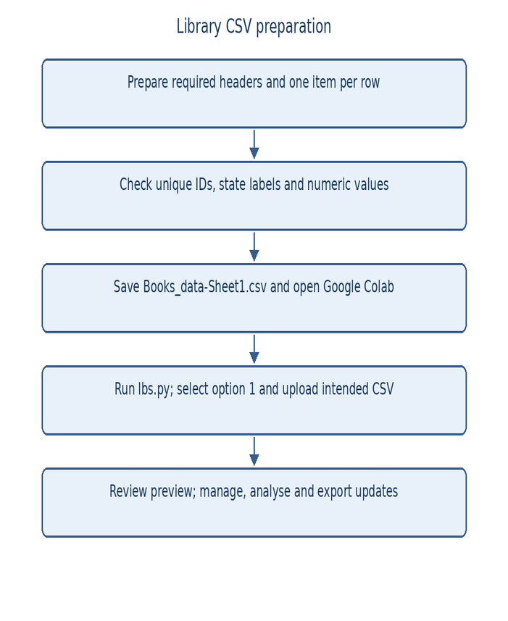

Figure 2.1: Steps to prepare and upload the library CSV

Files Used in the Project
The program uses an input CSV and a separately exported updated CSV, as described below.

      - Books_data-Sheet1.csv (input file): the expected catalogue filename. The report supplies 20 fictional records with all seven standard fields for reproducible examples.
      - updated_library_books.csv (export file): the current DataFrame written with index=False when option 9 is selected. The original input CSV is not overwritten.

Dataset Description
Each row represents one identified catalogue item. Its fields describe the title, author, category, circulation state, cumulative borrowing count and stored fine value. Five columns are required; the source creates missing analytical columns only when they are absent entirely. The demonstration CSV has 20 rows and seven columns.

Characteristics of the Dataset
      - Format: comma-separated values (.csv), read using pd.read_csv().
      - Size: 20 fictional book records and seven standard fields in the report sample.
      - Data types: bid, borrow_count and fine are numerical; title, author, category and status are textual.
      - Missing data: none in the fictional sample. Invalid entries in existing numeric columns cause load rejection.
      - Use: catalogue management, descriptive analysis, visualisation and available-book popularity ranking.

Features / Attributes
Table 2.1 lists the seven stored fields and six report-derived indicators. Derived indicators explain the sample only; they are not additional required input columns.

Table 2.1: Stored fields and report-derived catalogue indicators

S.No | Attribute | Type | Description (* derived in report)
1 | bid | Numerical | Unique whole-number catalogue identifier
2 | title | Text | Book title used in display and literal search
3 | author | Text | Author label used in display and literal search
4 | category | Text | Subject group used in search and aggregation
5 | status | Text | Current state: available or issued
6 | borrow_count | Numerical | Non-negative whole-number cumulative counter
7 | fine | Numerical | Finite non-negative stored amount in rupees
8 | is_available* | Derived | 1 when normalised status is available, else 0
9 | is_issued* | Derived | 1 when normalised status is issued, else 0
10 | category_count* | Derived | Number of sample items in a category
11 | borrowing_total* | Derived | Sum of borrow_count across selected records
12 | fine_total* | Derived | Sum of stored fine amounts in selected records
13 | availability_pct* | Derived | 100 × available records / total records

Categorical and Numerical Attributes
Text fields support display, search, grouping and status filtering. Numeric fields support item selection, validation, statistics and ranking. Category and status are not encoded for a learning algorithm. The additional indicator rows in Table 2.1 are derived explanatory measures, not columns required by lbs.py.

Operational Status Variable
The operational variable is status. available means the item can be issued; issued means it is already marked as borrowed. This is a stored catalogue state, not a prediction target. In the fictional sample, 14 of 20 items are available and six are issued, as shown in Table 2.2.

Table 2.2: Distribution of the operational status variable

status | Meaning | Books | Percentage
available | Can be issued | 14 | 70.00 %
issued | Already issued | 6 | 30.00 %
Total |  | 20 | 100.00 %

The sample availability percentage is 70%, calculated as 14 divided by 20. Current issued count and cumulative borrowing counts measure different things. Six items are currently issued, while borrow_count sums to 296. The latter cannot be interpreted as the number of loans during a particular month because no dates are recorded.

Dataset Statistics / Initial Exploration
The fictional sample contains 20 rows, seven columns, no missing entries and no duplicate full rows. The three stored numerical fields are bid, borrow_count and fine. Table 2.3 also describes derived status and category indicators for documentation; these indicators are not persisted input fields or extra analysis modules in the source.
Table 2.3: Numerical fields and derived indicators in the sample

Attribute (* derived) | Mean | Std. Dev. | Min | Median | Max
bid | 10.50 | 5.92 | 1.00 | 10.50 | 20.00
borrow_count | 14.80 | 9.16 | 2.00 | 13.00 | 33.00
fine | 12.50 | 16.50 | 0.00 | 5.00 | 50.00
available* | 0.70 | 0.47 | 0.00 | 1.00 | 1.00
issued* | 0.30 | 0.47 | 0.00 | 0.00 | 1.00
Programming* | 0.20 | 0.41 | 0.00 | 0.00 | 1.00
Science* | 0.20 | 0.41 | 0.00 | 0.00 | 1.00
Literature* | 0.20 | 0.41 | 0.00 | 0.00 | 1.00
History* | 0.20 | 0.41 | 0.00 | 0.00 | 1.00
Mathematics* | 0.20 | 0.41 | 0.00 | 0.00 | 1.00

Book identifiers are numeric but are not measurements of quality or popularity. Borrowing counts range from 2 to 33 in the sample, with mean 14.80 and median 13. Fine values sum to Rs. 250. These fictional stored amounts do not represent verified debts, collected revenue or a relationship between borrowing and overdue behaviour.

Commands Used for Initial Exploration
Initial exploration uses the following Pandas commands. The DataFrame is named books after successful loading. Table 2.4 explains how each command helps inspect the sample catalogue.
books = pd.read_csv("Books_data-Sheet1.csv")
print("Dataset shape:", books.shape)
print(books.isnull().sum())
print(books.duplicated().sum())
display(books.head())
Table 2.4: Commands used for the initial exploration

Command | What it tells us
books.shape | 20 rows and seven columns in the sample
books.isnull().sum() | Per-column missing values; zero in sample
books.duplicated().sum() | Repeated full rows; zero in sample
books.info() | Stored column types and non-null counts
books.head() | First five records for an input preview

Observations from the Initial Exploration
      - The dataset has three stored numerical fields: bid, borrow_count and fine.
      - Whole-number restrictions apply to book IDs and borrowing counts. Fine may contain decimal values.
      - Required status values are checked through a trimmed, lowercase view; descriptive blanks in imported text are not rejected.
      - The catalogue supports current-state comparisons but has no borrower, loan-date or outcome prediction field.

Data Quality Assessment
Before a dataset is used, its quality must be judged. The raw dataset was assessed with five common data quality dimensions, summarised in Table 2.5.

Table 2.5: Data quality assessment of the library catalogue

Dimension | Check | Finding / limitation
Completeness | books.isnull().sum() | No missing sample entries; imported descriptive blanks are not rejected
Uniqueness | Converted bid duplication check | 20 unique whole-number sample IDs
Consistency | Normalised status membership | Only available or issued accepted
Validity | Finite, non-negative numeric checks | Counts and IDs must be whole numbers
Timeliness | Inspect date fields | No dates: snapshot only, not a time series

The checks prevent invalid identities, unsupported states and unusable numeric values from being accepted. However,
the existence of title, author and category columns does not guarantee non-blank imported descriptions. Dataset information reports completeness; it does not repair those fields. The fictional sample is complete, but a real file still needs operator review before operational use.

Ethical Use and Licence of the Data
The report sample is fictional and contains no borrower names, contact details or loan histories. No external dataset licence is asserted because no library dataset was uploaded. A real catalogue should be used only with appropriate permission. Adding borrower information would require privacy safeguards and access controls that this notebook does not implement. Source code and software dependencies are acknowledged in the references.

CHAPTER 3

DATA PREPROCESSING

Data Collection / Loading
The CSV is loaded in Google Colab through pd.read_csv(), using the expected file if present or prompting for an upload. The loader normalises column names, rejects empty input, verifies the five required fields and checks identifiers, status and analytical values. On success it displays the count and first rows; on failure it prints a Load error and returns None.

Handling Missing Values
The loader distinguishes a missing column from missing cells. An absent borrow_count or fine column receives generated demonstration values. An existing numeric column with invalid or missing entries is rejected. This behaviour is not median or mode imputation, and the report does not claim that incomplete catalogue rows are automatically repaired.
The generator uses np.random.default_rng(42). Counts are drawn from 0 through 50, while fines are chosen from 0, 10, 20, 30, 50 or 100. A printed warning identifies added sample columns. Table 3.1 records the actual validation policy and the complete condition of the fictional sample.
Table 3.1: Sample completeness and source validation rules

Field / rule | Type | Missing | Missing % | Policy | Accepted/default
bid | Numeric | 0 | 0% | Reject invalid | Unique integer
title | Text | 0 | 0% | Column required | No imputation
author | Text | 0 | 0% | Column required | No imputation
category | Text | 0 | 0% | Column required | No imputation
status | Text | 0 | 0% | Validate states | available/issued
borrow_count | Numeric | 0 | 0% | Validate/create | Demo if absent
fine | Numeric | 0 | 0% | Validate/create | Demo if absent
Missing count column | Rule | N/A | N/A | Seeded integers | 0 through 50
Missing fine column | Rule | N/A | N/A | Seeded choices | 0,10,20,30,50,100
Existing numeric NaN | Rule | N/A | N/A | Reject file | No cell fill
Empty dataset | Rule | N/A | N/A | Reject file | No empty start

The fictional sample has no missing entries. The source validates existing numeric cells; it does not perform median or mode imputation.

Handling Duplicate / Inconsistent Data
The loader converts IDs numerically and rejects duplicates after conversion. dataset_info() separately reports fully duplicate rows. These checks serve different purposes: unique bid values identify items, while full-row duplicates diagnose repeated records. The sample has 20 unique IDs and no duplicate rows.
Status values are checked after trimming and lowercasing. Negative, missing or infinite analytical values are rejected, and borrowing counts must be whole numbers. Column-name cleaning standardises headers but does not rename unrelated field names. Imported text descriptions may still be blank and should be reviewed.
Table 3.2 compares the fictional input with its accepted in-memory catalogue.
Table 3.2: Dataset condition before and after preprocessing

Check | Input sample | Accepted sample
Rows | 20 | 20
Columns | 7 | 7
Missing values | 0 | 0
Duplicate rows | 0 | 0
Available books | 14 | 14
Issued books | 6 | 6

Feature Scaling
The numerical fields use different meanings and units: IDs identify books, borrow_count records cumulative activity, and fine stores a book-level amount. Feature scaling is not applied because the program performs direct validation, arithmetic, filtering and sorting rather than fitting a distance-based or gradient-based learning model.
Min-max scaling is also unnecessary for the implemented rules. Original counts and amounts are retained so the operator can interpret numerical summaries and recommendations directly.

Standardization
Numerical standardisation to mean zero and unit variance is not applied. The program instead standardises headers and uses normalised status comparisons. These are text-consistency operations, not statistical feature standardisation. NumPy and Pandas summaries retain the original field units.

Label Encoding
Label encoding is not applied. The status text remains available or issued, and categories remain readable strings. The recommendation routine filters and sorts records directly; it does not require numeric target labels or a trained classification model.

One-Hot Encoding
One-hot encoding is not applied. Category labels are used by search, groupby, category plots and an optional exact-normalised recommendation filter. The report derives a few indicator variables only to describe the sample; these do not change the uploaded application or its required schema.

Other Project-Specific Preprocessing
    - Schema check: loading stops if bid, title, author, category or status is absent.
    - Header cleaning: leading/trailing spaces are stripped and column names are lowercased.
    - Numeric checks: pd.to_numeric(errors="coerce") supports validation; IDs and counts must be whole numbers.
    - State checks: only available or issued is accepted; redundant issue and return requests are blocked.
    - Run-time input: menu choices are read as text and Book IDs are converted with int() before lookup.

CHAPTER 4

SYSTEM DESIGN AND METHODOLOGY

Proposed Methodology
The proposed system combines catalogue management with descriptive analysis. Its six functional stages produce visible, reviewable results while retaining a shared in-memory DataFrame:
    - Dataset loading: read the CSV or request an upload, then display the accepted preview.
    - Data exploration: inspect dimensions, types, missing values and duplicate rows.
    - Data validation: check required fields, unique IDs, status labels and numerical values.
    - Book management: search descriptions, list availability, issue, return and append new records.
    - Exploratory analysis: compute totals and category summaries, then display the five supported chart modes.
    - Ranking and export: recommend available items by popularity and download the updated catalogue.

System Workflow / Architecture
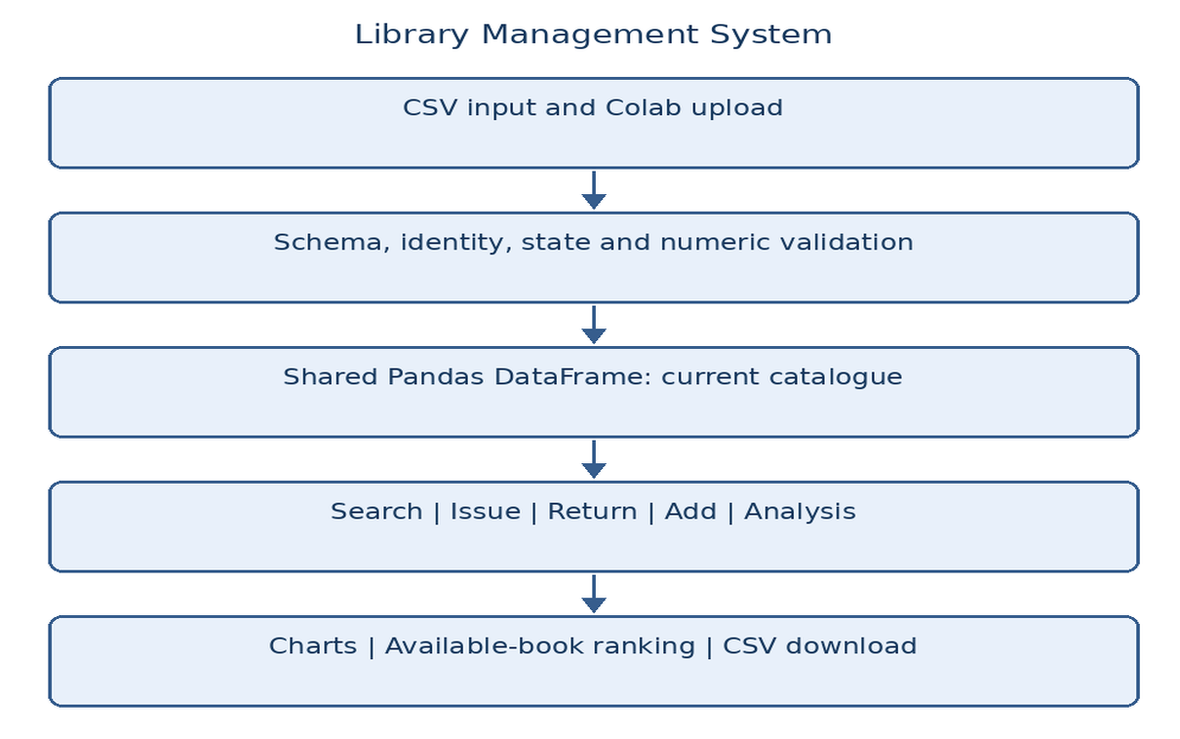
Figure 4.1 shows the layers of the application. CSV input passes through validation into the shared catalogue. Management functions update that state; analysis and recommendation functions read it. Tables and charts are displayed, and an explicit download writes the current state to a separate CSV.
Figure 4.1: Layered architecture of the Library Management System

Flowchart

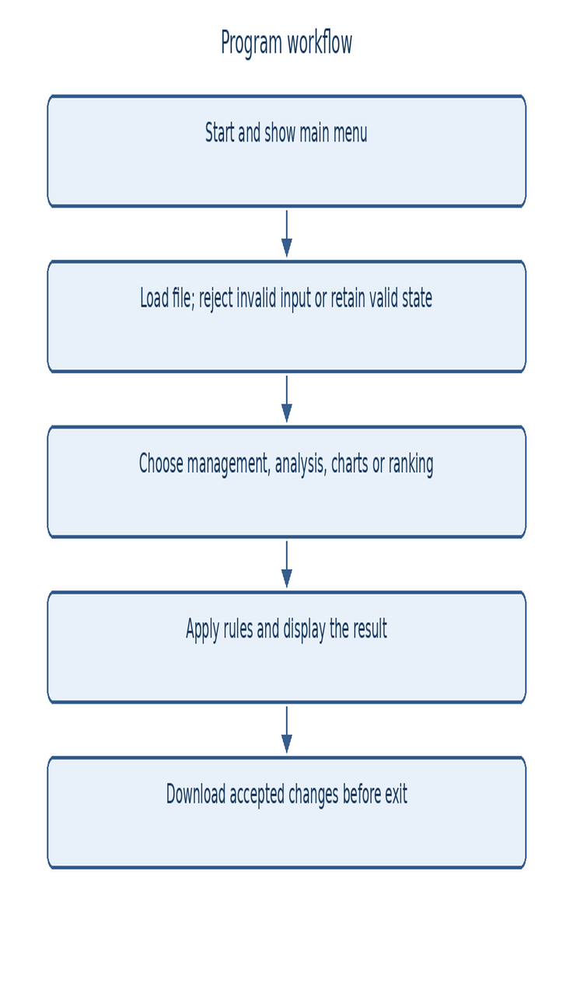
Figure 4.2 shows the main menu workflow, including validation failure, data-dependent actions and explicit export before exit.

Figure 4.2: Flowchart of the project workflow

Tools and Technologies Used
The intended environment is Google Colab. The hardware entries describe a comfortable demonstration setup rather than measured minimum requirements; a browser and access to the notebook service are the practical prerequisites.
Table 4.1: Hardware requirements

Component | Requirement
Processor | Intel Core i3 or above
RAM | Minimum 4 GB
Storage | 20 GB
Input devices | Keyboard and mouse
Output device | Monitor

Table 4.2: Software requirements and libraries

Category | Tool / Library | Purpose
Operating system | Browser-capable system | Access Google Colab
Language | Python 3 | Functions, menus and state rules
Environment | Google Colab | Interactive run and file transfer
Data handling | Pandas, NumPy | CSV, validation, grouping and statistics
Visualisation | Matplotlib | Histogram, bar, scatter, pie and dashboard
Ranking logic | Pandas filtering / sorting | Available-only popularity ordering
Display / files | IPython; Colab files | Render tables; upload and download

Algorithm / Recommendation Logic Used
The recommendation function uses filtering and sorting rather than a trained model. recommend_books() keeps available records, optionally restricts category and orders candidates by borrow_count descending. It resolves equal counts with bid ascending and displays at most five rows. The result is explainable but not personalised to a borrower.
Eligibility is determined by normalised status and, if entered, a casefolded exact category match. Ranking uses existing counts. The algorithm is:
    - Read an optional category using input(). A blank input means all categories. List distinct non-null categories to help the operator choose a valid label.
    - Rule 1: retain only books whose normalised status is available.
    - Rule 2: if a category is supplied, retain exact matches after whitespace trimming and casefolding.
    - Rule 3: sort by borrow_count descending, then bid ascending, and keep the first five records.
    - If no eligible records remain, show No books found. Otherwise display ID, title, author, category, count and status.

CHAPTER 5

IMPLEMENTATION

Development Environment
The uploaded source is implemented in Python 3 for Google Colab. It imports Pandas, NumPy, Matplotlib, os, google.colab.files and IPython.display. Run the complete program before selecting menu operations. The code sections cover validation, management, analysis, charting and ranking, and the appendix provides the supplied implementation.
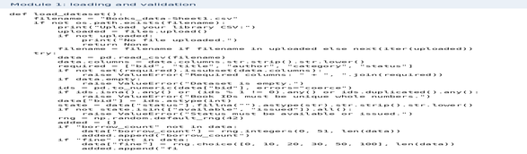
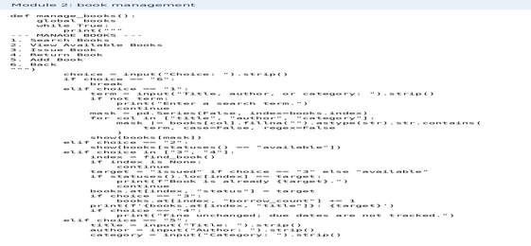
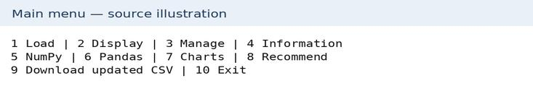

Figure 5.1: Library program modules and main menu illustration

Dataset Loading and Exploration
The loader reads the CSV, normalises headers and checks required fields before the main loop accepts the returned DataFrame:
data = pd.read_csv(filename)
data.columns = data.columns.str.strip().str.lower()
required = ["bid", "title", "author", "category", "status"]
print(data.shape)

Preprocessing Implementation
Existing IDs and analytical values are converted and checked. Missing analytical columns receive explicitly labelled sample values. Invalid cells are rejected rather than silently replaced:
ids = pd.to_numeric(data["bid"], errors="coerce")
if ids.isna().any() or (ids % 1 != 0).any():
raise ValueError("Book IDs must be whole numbers.")
if ids.duplicated().any():
raise ValueError("Book IDs must be unique.")
data["bid"] = ids.astype(int)
state = data["status"].fillna("").astype(str).str.strip().str.lower()

Exploratory Data Analysis (EDA)
The analysis modules calculate NumPy summaries and Pandas grouped results. Matplotlib provides a borrowing histogram, category bar chart, count-versus-fine scatter plot, status pie chart and combined dashboard. The following snippet illustrates a supported category plot:
counts = books["category"].fillna("Unknown").value_counts()
counts.plot.bar(ax=ax, color="teal", edgecolor="black")
plt.tight_layout()
plt.show()

Recommendation Module Implementation
The recommendation function first filters available books and then applies an optional category restriction. Eligible rows are sorted by cumulative borrow_count, with bid breaking ties,

and up to five results are displayed. No model training, future-outcome prediction or borrower-specific profile is used. Seeded demonstration counts produce demonstration rankings only.
def recommend_books():
category = input("Category (Enter for all): ").strip()
result = books[statuses() == "available"]
if category:
mask = result["category"].fillna("").astype(str).str.strip().str.casefold()
result = result[mask == category.casefold()]
result = result.sort_values(
["borrow_count", "bid"], ascending=[False, True]
).head(5)
print("Available books ranked by borrow count.")
show(result)

Important Code Explanation
Table 5.1: Key code elements and their purpose

Code element | Purpose
pd.read_csv() | Read the input catalogue
books.isnull().sum() | Count missing values by column
books.duplicated().sum() | Count fully repeated rows
pd.to_numeric() | Convert and validate numerical fields
statuses() | Normalise state labels for comparisons
value_counts() | Count states or categories
groupby("category").agg(...) | Calculate category counts, borrowing and fine totals
recommend_books() | Rank up to five available catalogue items
int(input()) | Read a numeric Book ID for lookup
pd.concat(...) | Append a new available book with zero counts
to_csv(..., index=False) | Export the current catalogue without row index

CHAPTER 6

DATA VISUALIZATION AND RESULTS

This chapter presents the application’s category, status, borrowing, fine and dashboard views. All example images are report illustrations derived from a fictional 20-book catalogue, not screenshots of an institutional deployment. The original source implements five chart modes; additional panels explain the same stored fields.

Bar Graph
The category bar graph counts catalogue items in each subject category.
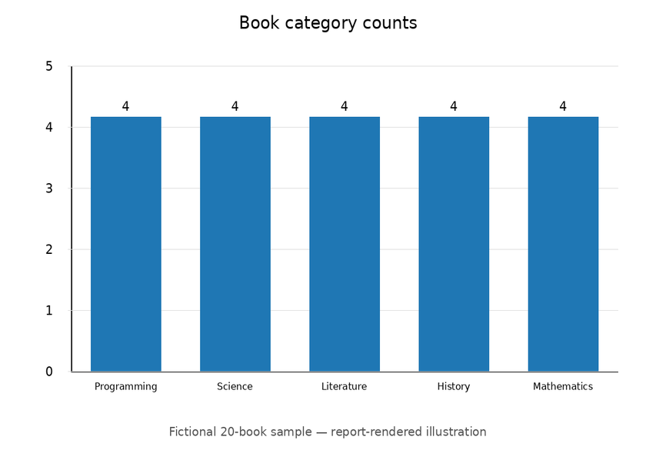

Figure 6.1: Number of books by category in the fictional sample
Interpretation: each of the five sample categories contains four records. Equal heights reflect the deliberately balanced demonstration catalogue, not a finding about a real collection. These bars count holdings, not cumulative borrowings or reader preferences.

Pie Chart
The status pie chart expresses current availability and issue counts as percentages.
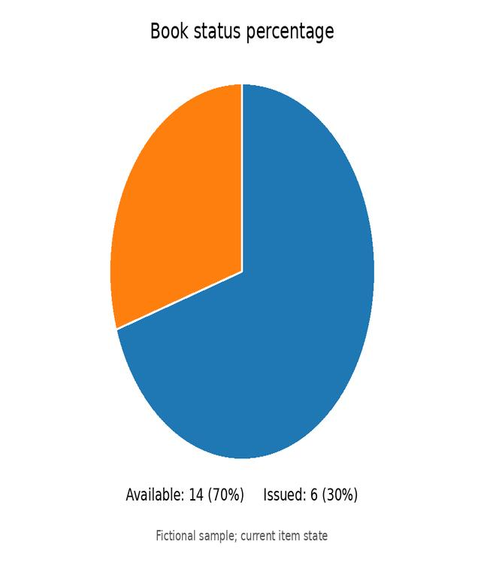

Figure 6.2: Book status percentage in the fictional sample
Interpretation: 14 available books account for 70% of the 20 records; six issued books account for 30%. These are current states. The chart does not measure the number of loans made over a month or how long an item has remained issued.

Histogram
The histogram uses ten bins to show the distribution of per-book borrowing counts.
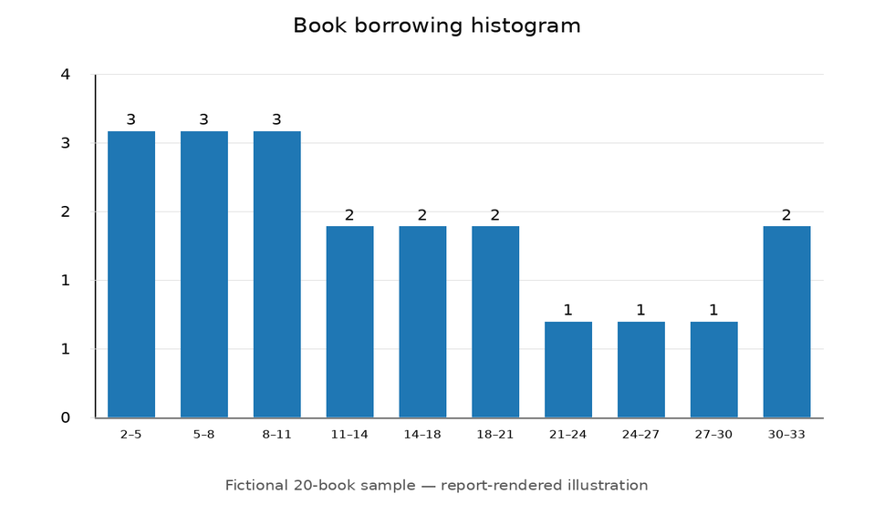

Figure 6.3: Distribution of sample book borrowing counts
Interpretation: the fictional counts range from 2 to 33, with mean 14.80 and median 13. Values describe cumulative activity recorded per item. No acquisition dates or observation window are supplied, so the chart cannot establish borrowing rates per year or compare equal periods of demand.

Availability Bar Chart
The dashboard status panel compares the number of available and issued items.
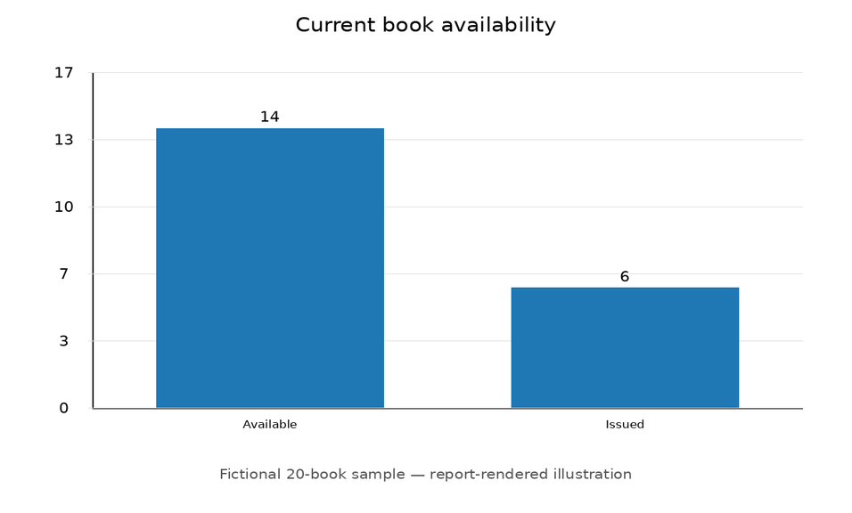

Figure 6.4: Available versus issued book counts
Interpretation: the baseline sample has 14 available and six issued items. Issuing one available item changes these to 13 and seven without changing the total of 20. Returning it restores availability but does not reduce the cumulative borrowing count. This panel is part of the supported dashboard, not a new box-plot module.

Category Borrowing Summary
The category summary compares cumulative borrowing totals calculated by Pandas groupby.
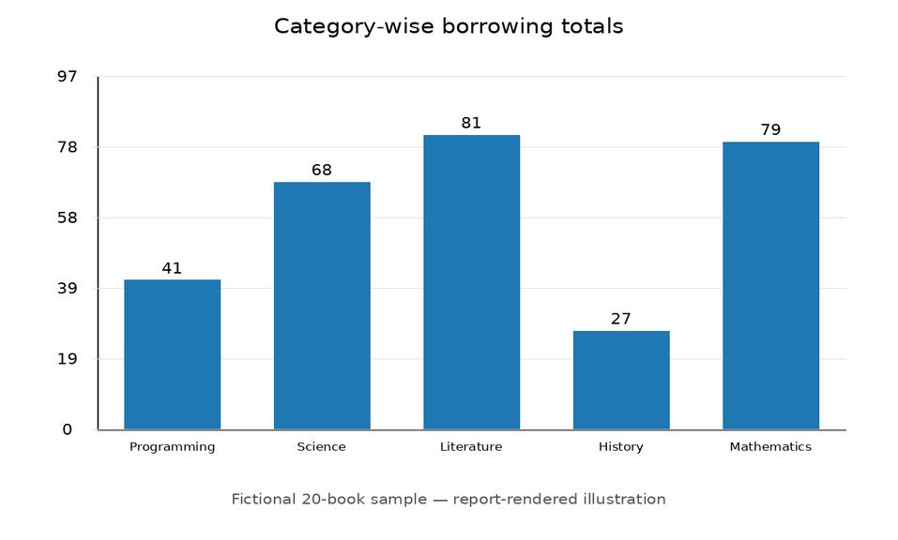

Figure 6.5: Category-wise borrowing totals from the sample
Interpretation: category totals add to the same 296 count shown by NumPy. Since every sample category has four records, ranking by category total gives the same order as ranking by mean count. This report-derived panel illustrates the grouped table; no line-chart routine is claimed in lbs.py.

Scatter Plot
The scatter plot places each book by borrowing count and stored fine amount.
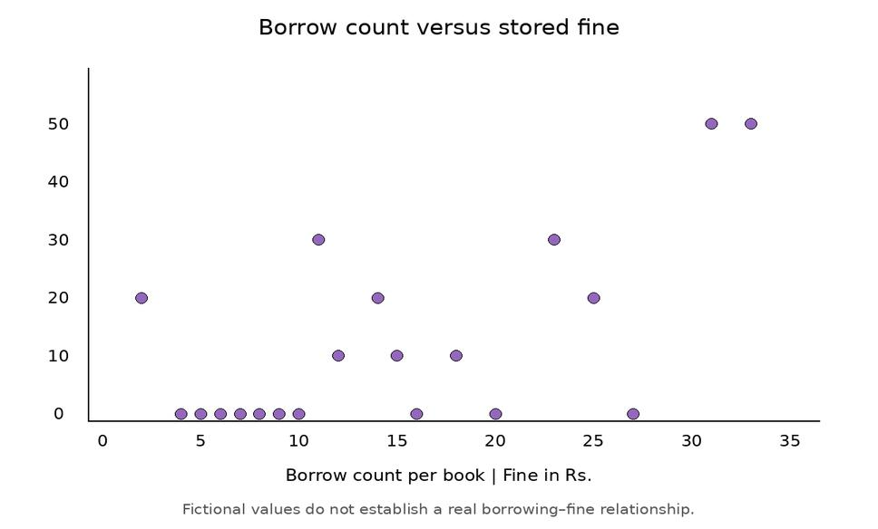

Figure 6.6: Borrow count versus stored fine amount
Interpretation: each point represents one fictional catalogue record. Overlap may hide identical pairs. The source warns that sample values do not establish a real borrowing–fine relationship. Fine is a stored book-level amount, not a calculated late-return charge or verified collected revenue.

Project-Specific Visualizations
The combined mode places current status counts alongside category inventory counts. It also prints total books and availability percentage before drawing its two subplots.

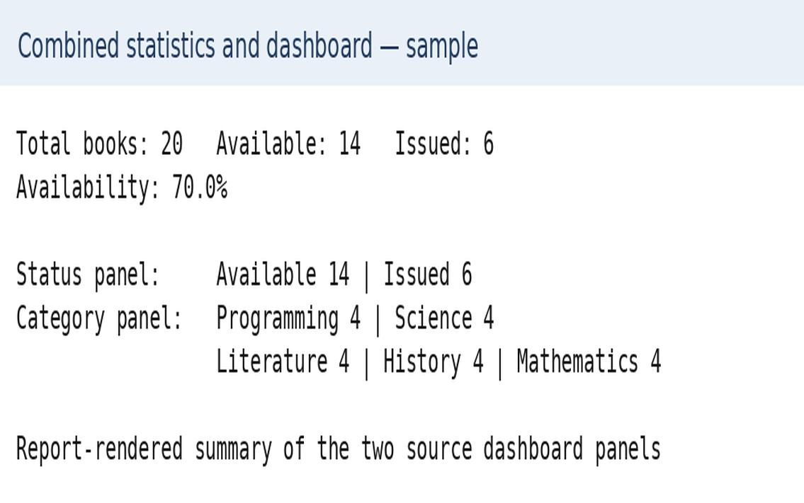

Figure 6.7: Combined availability and category dashboard
Interpretation: the dashboard presents a 20-item catalogue with 70% availability and four records in each category. It links two complementary views of the same table. It does not track overdue loans, calculate reservations, infer causality or produce a correlation heatmap.

Interpretation of Visualizations
The following tables cross-check the figures against the underlying fictional records. Table 6.1 groups borrowing counts into report-defined bands. Table 6.2 compares stored and derived indicators across current status groups. Table 6.3 records exact output measures and their meanings, avoiding unsupported claims about correlations.

Table 6.1: Availability by sample borrowing-count band

Borrow-count band | Books | Available | Availability
0–9 | 7 | 5 | 71.4%
10–19 | 7 | 5 | 71.4%
20–29 | 4 | 2 | 50.0%
30 and above | 2 | 2 | 100.0%

Table 6.2: Stored and derived averages by current book status

Attribute (* derived) | Available | Issued | Difference
bid | 10.50 | 10.50 | +0.00
borrow_count | 15.14 | 14.00 | +1.14
fine | 13.57 | 10.00 | +3.57
available* | 1.00 | 0.00 | +1.00
issued* | 0.00 | 1.00 | -1.00
Programming* | 0.21 | 0.17 | +0.05
Science* | 0.21 | 0.17 | +0.05
Literature* | 0.14 | 0.33 | -0.19
History* | 0.21 | 0.17 | +0.05
Mathematics* | 0.21 | 0.17 | +0.05
Table 6.3 summarises catalogue measures and implemented operations. Values describe the fictional sample or the source logic, not a predictive relationship.
Table 6.3: Catalogue measures and their interpretation

Measure / rule | Result / meaning
Catalogue records | 20 fictional items
Available items | 14 (70%)
Issued items | 6 (30%)
Borrowing total | 296 stored cumulative counts
Mean borrowing | 14.80 counts per item
Median borrowing | 13 counts per item
Fine total | Rs. 250 stored sample amounts
Issue rule | Change status; increment counter once
Return rule | Restore available; fine unchanged
Ranking rule | Available only; count descending; ID ascending

The charts and tables support the following descriptive observations. They refer to the fictional example catalogue and the supplied rules, not to an actual library or causes of reader behaviour:
    - Availability is a current-state measure: 14 of the 20 example items are available, giving 70
%. A successful issue reduces availability by one item; a return reverses that state change without reducing historical borrow_count.
    - Inventory and activity differ: every category has four sample records, but category borrowing totals differ because the per-book counters are unequal.
    - Borrowing totals are cumulative: the sum is 296, but no dates establish an observation period. It is therefore not a monthly or annual circulation count.
    - Fine values require caution: the sum is Rs. 250 in this fictional sample. The source does not link those amounts to patrons, calculate overdue days or record
whether any amount was collected.
    - Popularity ranking excludes issued items. A high-count issued book may appear in the Pandas top-five table but not in the available-book recommendation list.

CHAPTER 7

RECOMMENDATION MODULE AND ANALYSIS OF RESULTS

Recommendation Rules
The recommendation module is a deterministic function, recommend_books(), that ranks eligible catalogue items. It does not learn from data or predict a future outcome. It follows these filtering and sorting rules:
    - Rule 1 (availability): retain records whose normalised status is available.
    - Rule 2 (optional category): match the entered category after trimming and casefolding; leave blank for all categories.
    - Rule 3 (popularity): sort by borrow_count descending and use bid ascending to resolve equal counts.
    - Output limit: show at most five eligible records; print No books found. for an empty result.
    - Inputs: the category is entered by the operator. Availability, borrow_count and bid come from the loaded catalogue. No borrower profile or prediction label is required.

Sample Recommendations
Table 7.1 records five recommendation scenarios for the fictional catalogue. Results follow directly from availability filtering, optional category selection and ordering by borrow_count. The report includes a captured function output and distinguishes it from an actual Colab browser screenshot.
Table 7.1: Sample cases from the recommendation module

Category input / case | Eligibility rule | Result | Explana  tion
Programming | Available + category | IDs 11, 16, 1 | Counts 7, 6, 5
Blank category | All available | Up to five | Highest count first
Unknown category | Exact category | No books found | No eligible records
Issued high-count item | Availability first | Excluded | ID 6 is issued
Equal borrowing counts | ID tie-break | Lower ID first | Deterministic order

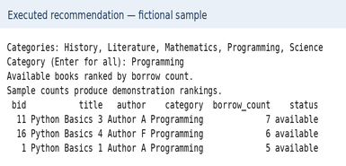
Figure 7.1: Executed recommendation output for Programming

Result Interpretation
The ranking is deterministic: the same catalogue and category produce the same order. Each recommended item is available and can be traced to its count and ID. This transparency makes the method suitable for a beginner demonstration, but no accuracy score is appropriate because the source does not train or evaluate a prediction model.
For Programming, the sample recommends IDs 11, 16 and 1 with counts 7, 6 and 5. ID 6 has a higher count of 23 but is issued, so it is excluded. This illustrates the difference between an unrestricted most-borrowed table and an available-only recommendation list.

Discussion
The rules have clear limits. Cumulative popularity does not establish personal relevance, and old items may rank above useful new arrivals. The optional category match is exact after normalisation rather than a substring search. Generated counts support demonstrations only. There is no reader history, recency measure, content similarity model or evaluation against future borrowing.
The output should therefore be described as a transparent popularity-based suggestion list. A future implementation could record dated loans and offer recent-use or new-arrival views. Such enhancements require extra data and are not existing features of lbs.py.

CHAPTER 8

OUTPUT SCREENSHOTS

This chapter presents report-rendered captures and illustrations using the fictional 20-record sample. Statistics, search and ranking outputs come from supplied functions called with controlled input. Upload/download panels are source-based usage illustrations, not evidence of a browser interaction or live library deployment.

Input / Dataset Screenshots
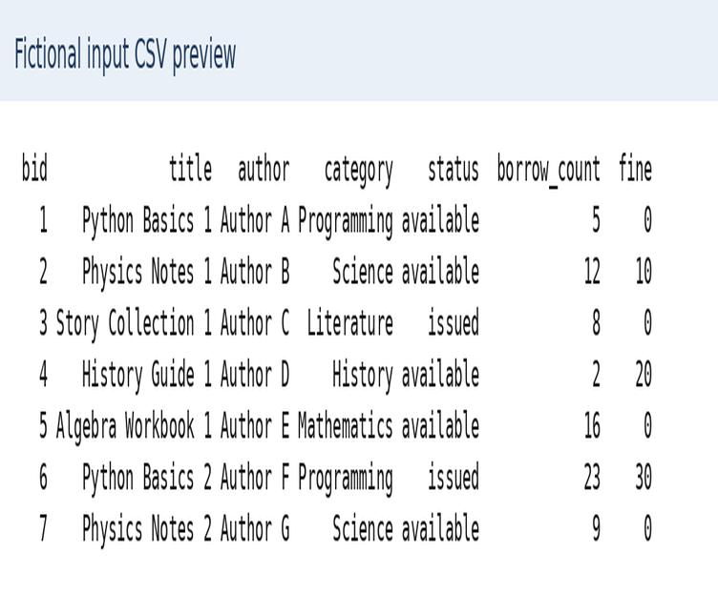
Figure 8.1: Fictional input catalogue preview (Books_data-Sheet1.csv)

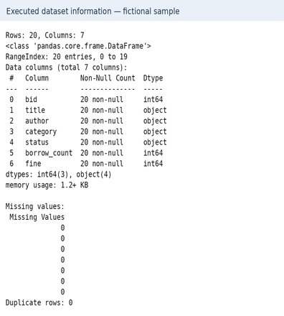
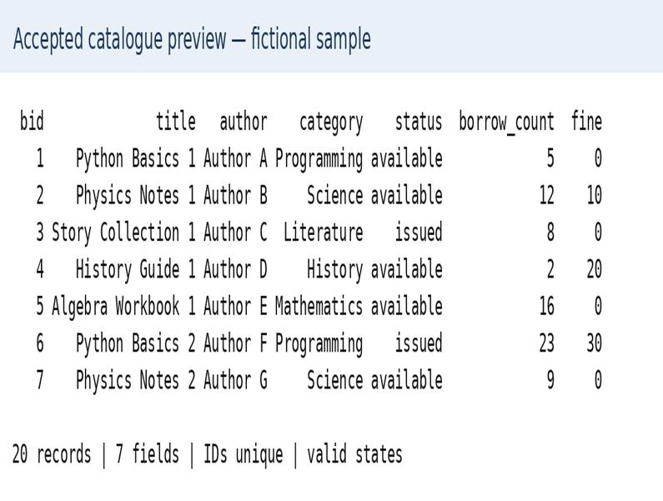
Figure 8.2: Accepted in-memory library catalogue preview

Figure 8.3: Executed dataset shape, missing values and duplicates

Preprocessing Outputs

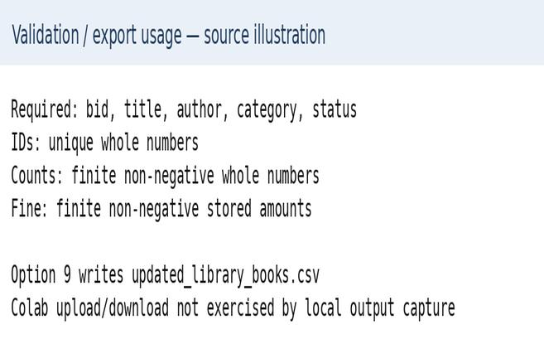
Figure 8.4: Validation rules and export usage illustration

Visualization Outputs
The supported charts and explanatory panels are shown in Chapter 6. Numerical and grouped summaries below use the unchanged fictional sample. Management changes should be exported separately to keep the baseline reproducible.
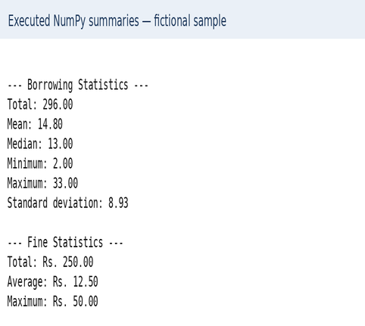

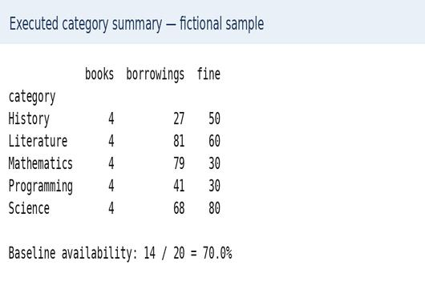

Figure 8.5: Sample counts, availability and numerical summaries

Recommendation / Analysis Outputs
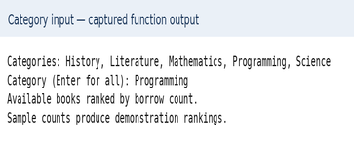

Figure 8.6: Category input and available-book selection

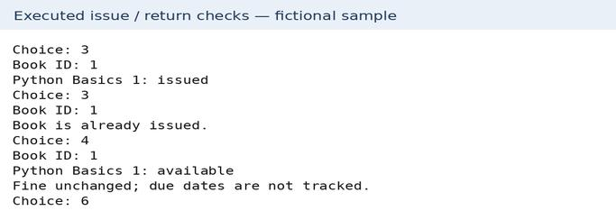

Figure 8.7: Ranked sample results and circulation output

CHAPTER 9

CONCLUSION AND FUTURE ENHANCEMENTS

Conclusion
This project documents a Python catalogue workflow from validated CSV input through book management, analysis, visualisation and export. It supports search, availability checks, issue, return and addition. The fictional 20-book example has 14 available items, six issued items and a cumulative borrowing count of 296. These are reproducible demonstrations, not findings from an uploaded institutional dataset.
The available-book recommendation function filters eligible items and sorts them by stored popularity. It is deterministic and explainable but is not a trained predictive model. Together, the modules illustrate Pandas filtering and grouping, NumPy summaries, Matplotlib charting and basic state-transition rules in an introductory project.

Limitations
    - The catalogue has no separate borrower, loan, physical-copy or bibliographic-title entities.
    - No due dates or loan timestamps are stored, so overdue charges cannot be calculated.
    - Blank imported title, author and category values are not rejected merely because the columns exist.
    - The program runs through notebook input and has no web interface or role-based authentication.
    - Changes remain in memory until explicitly downloaded. The current-state CSV does not preserve an audit trail of individual issues and returns, and the program has no concurrent-write protection.
    - Recommendations use cumulative counts only; generated demonstration values are not evidence of real preferences.

Future Enhancements
    - Add database persistence with separate title, copy, member and loan records.
    - Record issue, due and return dates and apply a documented fine policy instead of leaving stored amounts unchanged.
    - Separate validation, business rules and presentation, then build an authenticated form-based interface with appropriate permissions.
    - Add automated tests for rejected files, invalid transitions, new-ID generation and CSV export/reload consistency.
    - Extend reporting with dated circulation trends, reservations and transparent recent-popularity or new-arrival suggestions.

REFERENCES

- W. McKinney, "Data Structures for Statistical Computing in Python," in Proceedings of the 9th Python in Science Conference, 2010, pp. 56–61.
- C. R. Harris et al., "Array programming with NumPy," Nature, vol. 585, pp. 357–362, 2020.
- J. D. Hunter, "Matplotlib: A 2D Graphics Environment," Computing in Science & Engineering, vol. 9, no. 3, pp. 90–95, 2007.
- Uploaded project source, “lbs.py”: library catalogue management, analysis, charting and recommendation implementation.
- Pandas Development Team, "pandas documentation," https://pandas.pydata.org/docs/
- Google, "Colaboratory: Frequently asked questions," https://research.google.com/colaboratory/faq.html
- Project demonstration data: Books_data-Sheet1.csv, a fictional 20-book catalogue prepared for this report. No external library dataset was supplied or attributed.

APPENDIX – SOURCE CODE

The supplied lbs.py implementation is reproduced below in its original execution order. The listing contains loading and validation, book management, analysis, charting, ranking and the interactive main menu. Google Colab upload and download calls require the intended notebook environment.

import os
import numpy as np
import pandas as pd
import matplotlib.pyplot as plt
from google.colab import files
from IPython.display import display
books = None
def show(data):
if data.empty:
print("No books found.")
else:
display(data.reset_index(drop=True))
def statuses():
return books["status"].fillna("").astype(str).str.strip().str.lower()
def load_dataset():
filename = "Books_data-Sheet1.csv"
if not os.path.exists(filename):
print("Upload your library CSV:")
uploaded = files.upload()
if not uploaded:
print("No file uploaded.")
return None
filename = filename if filename in uploaded else next(iter(uploaded))
try:
data = pd.read_csv(filename)
data.columns = data.columns.str.strip().str.lower()
required = ["bid", "title", "author", "category", "status"]
if not set(required).issubset(data.columns):
raise ValueError("Required columns: " + ", ".join(required))
if data.empty:
raise ValueError("Dataset is empty.")
ids = pd.to_numeric(data["bid"], errors="coerce")
if ids.isna().any() or (ids % 1 != 0).any() or ids.duplicated().any():

raise ValueError("Book IDs must be unique whole numbers.")
data["bid"] = ids.astype(int)
state = data["status"].fillna("").astype(str).str.strip().str.lower()
if not state.isin(["available", "issued"]).all():
raise ValueError("Status must be available or issued.")
rng = np.random.default_rng(42)
added = []
if "borrow_count" not in data:
data["borrow_count"] = rng.integers(0, 51, len(data))
added.append("borrow_count")
if "fine" not in data:
data["fine"] = rng.choice([0, 10, 20, 30, 50, 100], len(data))
added.append("fine")
for col in ["borrow_count", "fine"]:
values = pd.to_numeric(data[col], errors="coerce")
if values.isna().any() or not np.isfinite(values).all() or (values < 0).any():
raise ValueError(f"{col} must contain finite, non-negative numbers.")
data[col] = values
if (data["borrow_count"] % 1 != 0).any():
raise ValueError("Borrow counts must be whole numbers.")
data["borrow_count"] = data["borrow_count"].astype(int)
print(f"Loaded {len(data)} books.")
if added:
print("Sample columns added:", ", ".join(added))
print("These are demonstration values, not actual records.")
show(data.head())
return data
except Exception as error:
print("Load error:", error)
return None
def find_book():
try:
book_id = int(input("Book ID: "))
except ValueError:
print("Enter a numeric Book ID.")
return None
matches = books.index[books["bid"] == book_id]
if len(matches) == 0:
print("Book ID not found.")
return None
print("\nCleaned dataset saved as:", output_file)
return matches[0]
def manage_books():
global books
while True:
print("""

--- MANAGE BOOKS ---
1. Search Books
2. View Available Books
3. Issue Book
4. Return Book
5. Add Book
6. Back
""")

choice = input("Choice: ").strip()
if choice == "6":
break
elif choice == "1":
term = input("Title, author, or category: ").strip()
if not term:
print("Enter a search term.")
continue
mask = pd.Series(False, index=books.index)

for col in ["title", "author", "category"]:
mask |= books[col].fillna("").astype(str).str.contains(
term, case=False, regex=False
)
show(books[mask])
elif choice == "2":
show(books[statuses() == "available"])
elif choice in ["3", "4"]:
index = find_book()
if index is None:
continue
target = "issued" if choice == "3" else "available"
if statuses().loc[index] == target:
print(f"Book is already {target}.")
continue
books.at[index, "status"] = target
if choice == "3":
books.at[index, "borrow_count"] += 1
print(f'{books.at[index, "title"]}: {target}')
if choice == "4":

print("Fine unchanged; due dates are not tracked.")
elif choice == "5":
title = input("Title: ").strip()
author = input("Author: ").strip()
category = input("Category: ").strip()
if not all([title, author, category]):
print("All fields are required.")
continue
new_id = int(books["bid"].max()) + 1
record = dict(bid=new_id, title=title, author=author,
category=category, status="available",
borrow_count=0, fine=0)

books = pd.concat([books, pd.DataFrame([record])], ignore_index=True)
print(f"Book added. ID: {new_id}")
else:
print("Invalid choice.")
def dataset_info():
print(f"Rows: {books.shape[0]}, Columns: {books.shape[1]}")
books.info()
print("\nMissing values:")
display(books.isnull().sum().rename("Missing Values").to_frame())
print("Duplicate rows:", books.duplicated().sum())
def numpy_analysis():
borrow = books["borrow_count"].to_numpy()
fine = books["fine"].to_numpy()
print("\n--- Borrowing Statistics ---")
for label, function in [
("Total", np.sum), ("Mean", np.mean), ("Median", np.median),

("Minimum", np.min), ("Maximum", np.max), ("Standard deviation", np.std)
]:
print(f"{label}: {function(borrow):.2f}")
print("\n--- Fine Statistics ---")
print(f"Total: Rs. {np.sum(fine):.2f}")
print(f"Average: Rs. {np.mean(fine):.2f}")
print(f"Maximum: Rs. {np.max(fine):.2f}")
def pandas_analysis():
print("\nNumerical summary:")

display(books[["borrow_count", "fine"]].describe())
print("\nCategory-wise analysis:")
display(books.groupby("category", dropna=False).agg(
total_books=("bid", "size"),
total_borrowings=("borrow_count", "sum"),
average_borrowings=("borrow_count", "mean"),
total_fine=("fine", "sum")
).round(2))
print("\nStatus counts:")
display(statuses().value_counts().rename("Book Count").to_frame())
print("\nTop 5 most borrowed books:")
show(books.nlargest(5, "borrow_count")[
["bid", "title", "author", "borrow_count", "status"]
])
def draw_chart(kind):

counts = books["category"].fillna("Unknown").value_counts()
if kind == "5":
state = statuses().to_numpy()
available = int(np.count_nonzero(state == "available"))
issued = int(np.count_nonzero(state == "issued"))
print(f"Total: {len(books)}, Available: {available}, Issued: {issued}")
print(f"Availability: {available / len(books):.1%}")
fig, axes = plt.subplots(1, 2, figsize=(15, 7))

axes[0].bar(["Available", "Issued"], [available, issued],
color=["seagreen", "tomato"])
axes[0].set(title="Book Availability", ylabel="Number of Books")
counts.sort_values().plot.barh(ax=axes[1], color="steelblue")
axes[1].set(title="Books by Category", xlabel="Number of Books")
else:
fig, ax = plt.subplots(figsize=(11, 6))
if kind == "1":
ax.hist(books["borrow_count"], bins=10,

color="skyblue", edgecolor="black")
ax.set(title="Book Borrowing Histogram",
xlabel="Borrow Count per Book", ylabel="Number of Books")
elif kind == "2":
counts.plot.bar(ax=ax, color="teal", edgecolor="black")
ax.set(title="Book Category Bar Chart",
xlabel="Category", ylabel="Number of Books")

plt.setp(ax.get_xticklabels(), rotation=60, ha="right")
elif kind == "3":
ax.scatter(books["borrow_count"], books["fine"],
color="purple", alpha=0.65, edgecolors="black")
ax.set(title="Borrow Count vs Fine",

xlabel="Borrow Count per Book", ylabel="Fine per Book (Rs.)")
ax.grid(alpha=0.3)
print("Sample values do not establish a real borrowing–fine relationship.")
elif kind == "4":
state = statuses().value_counts()

ax.pie(state.values, labels=state.index,
autopct="%1.1f%%", startangle=90)
ax.set_title("Book Status Pie Chart")
ax.axis("equal")
plt.tight_layout()
plt.show()

def charts_menu():
while True:
print("""
--- CHARTS AND STATISTICS ---
1. Borrowing Histogram
2. Category Bar Chart
3. Borrow Count vs Fine Scatter Plot
4. Book Status Pie Chart
5. Combined Statistics and Charts
6. Show All Chartsk
""")
choice = input("Choice: ").strip()
if choice == "7":
break
elif choice == "6":
for kind in ["1", "2", "3", "4", "5"]:
draw_chart(kind)
elif choice in ["1", "2", "3", "4", "5"]:
draw_chart(choice)
else:
print("Invalid choice.")
def recommend_books():
print("Categories:", ", ".join(sorted(
books["category"].dropna().astype(str).unique()
)))
category = input("Category (Enter for all): ").strip()
result = books[statuses() == "available"]
if category:
mask = result["category"].fillna("").astype(str).str.strip().str.casefold()
result = result[mask == category.casefold()]
result = result.sort_values(
["borrow_count", "bid"], ascending=[False, True]
).head(5)
print("Available books ranked by borrow count.")
print("Sample counts produce demonstration rankings.")

show(result[["bid", "title", "author", "category", "borrow_count", "status"]])
while True:
print("""
================================================
LIBRARY MANAGEMENT AND DATA ANALYSIS SYSTEM
================================================
1. Create / Load Dataset
2. Display All Books
3. Manage Books
4. Dataset Information
5. NumPy Statistical Analysis
6. Pandas Data Analysis
7. Charts and Statistics
8. Book Recommendation
9. Download Updated Dataset
10. Exit
================================================
""")
choice = input("Enter your choice (1-10): ").strip()
if choice == "10":

print("Session ended. Only downloaded changes are saved outside Colab.")
break
elif choice == "1":
if books is not None:
if input("Reload and discard current changes? (yes/no): ").strip().lower() != "yes":
continue
loaded = load_dataset()
if loaded is not None:
books = loaded
elif choice not in [str(i) for i in range(2, 10)]:
print("Invalid choice.")

elif books is None:
print("Select option 1 first.")
elif choice == "9":
books.to_csv("updated_library_books.csv", index=False)
files.download("updated_library_books.csv")

print("Download requested. Original CSV is not overwritten.")
else:
actions = {"2": lambda: show(books), "3": manage_books,
"4": dataset_info, "5": numpy_analysis,
"6": pandas_analysis, "7": charts_menu,
"8": recommend_books}
actions[choice]()

